**DBMS - Transaction**

A transaction can be defined as a group of tasks. A single task is the minimum processing unit which cannot be divided further.

Let’s take an example of a simple transaction. Suppose a bank employee transfers Rs 500 from A's account to B's account. This very simple and small transaction involves several low-level tasks.

**A’s Account**

Open_Account(A)

Old_Balance = A.balance

New_Balance = Old_Balance - 500

A.balance = New_Balance

Close_Account(A)

**B’s Account**

Open_Account(B)

Old_Balance = B.balance

New_Balance = Old_Balance + 500

B.balance = New_Balance

Close_Account(B)

## ACID Properties

**A transaction is a very small unit of a program and it may contain several low-level tasks**. A transaction in a database system must maintain **A**tomicity, **C**onsistency, **I**solation, and **D**urability − commonly known as ACID properties − in order to ensure accuracy, completeness, and data integrity.

* **Atomicity** − This property states that a transaction must be treated as an atomic unit, that is, either all of its operations are executed or none. There must be no state in a database where a transaction is left partially completed. States should be defined either before the execution of the transaction or after the execution/abortion/failure of the transaction.
* **Consistency** − The database must remain in a consistent state after any transaction. No transaction should have any adverse effect on the data residing in the database. If the database was in a consistent state before the execution of a transaction, it must remain consistent after the execution of the transaction as well.
* **Durability** − The database should be durable enough to hold all its latest updates even if the system fails or restarts. If a transaction updates a chunk of data in a database and commits, then the database will hold the modified data. If a transaction commits but the system fails before the data could be written on to the disk, then that data will be updated once the system springs back into action.
* **Isolation** − In a database system where more than one transaction are being executed simultaneously and in parallel, the property of isolation states that all the transactions will be carried out and executed as if it is the only transaction in the system. No transaction will affect the existence of any other transaction.

## Serializability

When multiple transactions are being executed by the operating system in a multiprogramming environment, there are possibilities that instructions of one transaction are interleaved with some other transaction.

* **Schedule** − A chronological execution sequence of a transaction is called a schedule. A schedule can have many transactions in it, each comprising of a number of instructions/tasks.
* **Serial Schedule** − It is a schedule in which transactions are aligned in such a way that one transaction is executed first. When the first transaction completes its cycle, then the next transaction is executed. Transactions are ordered one after the other. This type of schedule is called a serial schedule, as transactions are executed in a serial manner.

In a multi-transaction environment, serial schedules are considered as a benchmark. The execution sequence of an instruction in a transaction cannot be changed, but two transactions can have their instructions executed in a random fashion. This execution does no harm if two transactions are mutually independent and working on different segments of data; but in case these two transactions are working on the same data, then the results may vary. This ever-varying result may bring the database to an inconsistent state.

To resolve this problem, we allow parallel execution of a transaction schedule, if its transactions are either serializable or have some equivalence relation among them.

## Equivalence Schedules

An equivalence schedule can be of the following types −

### Result Equivalence

If two schedules produce the same result after execution, they are said to be result equivalent. They may yield the same result for some value and different results for another set of values. That's why this equivalence is not generally considered significant.

### View Equivalence

Two schedules would be view equivalence if the transactions in both the schedules perform similar actions in a similar manner.

For example −

* If T reads the initial data in S1, then it also reads the initial data in S2.
* If T reads the value written by J in S1, then it also reads the value written by J in S2.
* If T performs the final write on the data value in S1, then it also performs the final write on the data value in S2.

### Conflict Equivalence

Two schedules would be conflicting if they have the following properties −

* Both belong to separate transactions.
* Both accesses the same data item.
* At least one of them is "write" operation.

Two schedules having multiple transactions with conflicting operations are said to be conflict equivalent if and only if −

* Both the schedules contain the same set of Transactions.
* The order of conflicting pairs of operation is maintained in both the schedules.

**Note** − View equivalent schedules are view serializable and conflict equivalent schedules are conflict serializable. All conflict serializable schedules are view serializable too.

## States of Transactions

A transaction in a database can be in one of the following states −

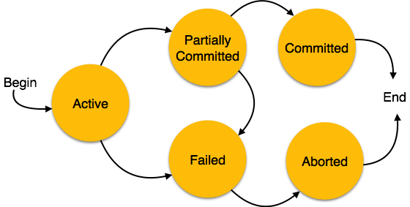

* **Active** − In this state, the transaction is being executed. This is the initial state of every transaction.
* **Partially Committed** − When a transaction executes its final operation, it is said to be in a partially committed state.
* **Failed** − A transaction is said to be in a failed state if any of the checks made by the database recovery system fails. A failed transaction can no longer proceed further.
* **Aborted** − If any of the checks fails and the transaction has reached a failed state, then the recovery manager rolls back all its write operations on the database to bring the database back to its original state where it was prior to the execution of the transaction. Transactions in this state are called aborted. The database recovery module can select one of the two operations after a transaction aborts −
  + Re-start the transaction
  + Kill the transaction
* **Committed** − If a transaction executes all its operations successfully, it is said to be committed. All its effects are now permanently established on the database system.

# DBMS - Data Backup

## Loss of Volatile Storage

A volatile storage like RAM stores all the active logs, disk buffers, and related data. In addition, it stores all the transactions that are being currently executed. What happens if such a volatile storage crashes abruptly? It would obviously take away all the logs and active copies of the database. It makes recovery almost impossible, as everything that is required to recover the data is lost.

Following techniques may be adopted in case of loss of volatile storage −

* We can have **checkpoints** at multiple stages so as to save the contents of the database periodically.
* A state of active database in the volatile memory can be periodically **dumped** onto a stable storage, which may also contain logs and active transactions and buffer blocks.
* <dump> can be marked on a log file, whenever the database contents are dumped from a non-volatile memory to a stable one.

### Recovery

* When the system recovers from a failure, it can restore the latest dump.
* It can maintain a redo-list and an undo-list as checkpoints.
* It can recover the system by consulting undo-redo lists to restore the state of all transactions up to the last checkpoint.

## Database Backup & Recovery from Catastrophic Failure

A catastrophic failure is one where a stable, secondary storage device gets corrupt. With the storage device, all the valuable data that is stored inside is lost. We have two different strategies to recover data from such a catastrophic failure −

* Remote backup & minu; Here a backup copy of the database is stored at a remote location from where it can be restored in case of a catastrophe.
* Alternatively, database backups can be taken on magnetic tapes and stored at a safer place. This backup can later be transferred onto a freshly installed database to bring it to the point of backup.

Grown-up databases are too bulky to be frequently backed up. In such cases, we have techniques where we can restore a database just by looking at its logs. So, all that we need to do here is to take a backup of all the logs at frequent intervals of time. The database can be backed up once a week, and the logs being very small can be backed up every day or as frequently as possible.

## Remote Backup

Remote backup provides a sense of security in case the primary location where the database is located gets destroyed. Remote backup can be offline or real-time or online. In case it is offline, it is maintained manually.

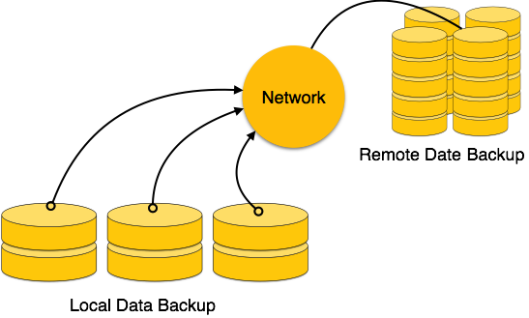

Online backup systems are more real-time and lifesavers for database administrators and investors. An online backup system is a mechanism where every bit of the real-time data is backed up simultaneously at two distant places. One of them is directly connected to the system and the other one is kept at a remote place as backup.

## As soon as the primary database storage fails, the backup system senses the failure and switches the user system to the remote storage. Sometimes this is so instant that the users can’t even realize a failure.

## Failure Classification

To see where the problem has occurred, we generalize a failure into various categories, as follows −

### Transaction failure

A transaction has to abort when it fails to execute or when it reaches a point from where it can’t go any further. This is called transaction failure where only a few transactions or processes are hurt.

Reasons for a transaction failure could be −

* **Logical errors** − Where a transaction cannot complete because it has some code error or any internal error condition.
* **System errors** − Where the database system itself terminates an active transaction because the DBMS is not able to execute it, or it has to stop because of some system condition. For example, in case of deadlock or resource unavailability, the system aborts an active transaction.

### System Crash

There are problems − external to the system − that may cause the system to stop abruptly and cause the system to crash. For example, interruptions in power supply may cause the failure of underlying hardware or software failure.

Examples may include operating system errors.

### Disk Failure

In early days of technology evolution, it was a common problem where hard-disk drives or storage drives used to fail frequently.

Disk failures include formation of bad sectors, unreachability to the disk, disk head crash or any other failure, which destroys all or a part of disk storage.

## Storage Structure

We have already described the storage system. In brief, the storage structure can be divided into two categories −

* **Volatile storage** − As the name suggests, a volatile storage cannot survive system crashes. Volatile storage devices are placed very close to the CPU; normally they are embedded onto the chipset itself. For example, main memory and cache memory are examples of volatile storage. They are fast but can store only a small amount of information.
* **Non-volatile storage** − These memories are made to survive system crashes. They are huge in data storage capacity, but slower in accessibility. Examples may include hard-disks, magnetic tapes, flash memory, and non-volatile (battery backed up) RAM.

## Recovery and Atomicity

When a system crashes, it may have several transactions being executed and various files opened for them to modify the data items. Transactions are made of various operations, which are atomic in nature. But according to ACID properties of DBMS, atomicity of transactions as a whole must be maintained, that is, either all the operations are executed or none.

When a DBMS recovers from a crash, it should maintain the following −

* It should check the states of all the transactions, which were being executed.
* A transaction may be in the middle of some operation; the DBMS must ensure the atomicity of the transaction in this case.
* It should check whether the transaction can be completed now or it needs to be rolled back.
* No transactions would be allowed to leave the DBMS in an inconsistent state.

There are two types of techniques, which can help a DBMS in recovering as well as maintaining the atomicity of a transaction −

* Maintaining the logs of each transaction, and writing them onto some stable storage before actually modifying the database.
* Maintaining shadow paging, where the changes are done on a volatile memory, and later, the actual database is updated.

The database can be modified using two approaches −

* **Deferred database modification** − All logs are written on to the stable storage and the database is updated when a transaction commits.
* **Immediate database modification** − Each log follows an actual database modification. That is, the database is modified immediately after every operation.

## Recovery with Concurrent Transactions

When more than one transaction is being executed in parallel, the logs are interleaved. At the time of recovery, it would become hard for the recovery system to backtrack all logs, and then start recovering. To ease this situation, most modern DBMS use the concept of 'checkpoints'.

### Checkpoint

Keeping and maintaining logs in real time and in real environment may fill out all the memory space available in the system. As time passes, the log file may grow too big to be handled at all. Checkpoint is a mechanism where all the previous logs are removed from the system and stored permanently in a storage disk. Checkpoint declares a point before which the DBMS was in consistent state, and all the transactions were committed.

### Recovery

When a system with concurrent transactions crashes and recovers, it behaves in the following manner −

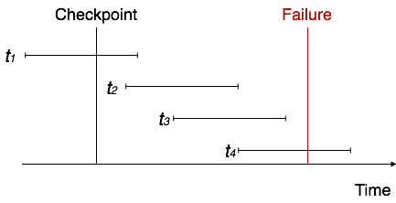

* The recovery system reads the logs backwards from the end to the last checkpoint.
* It maintains two lists, an undo-list and a redo-list.
* If the recovery system sees a log with <Tn, start> and <Tn, Commit> or just <Tn, Commit>, it puts the transaction in the redo-list.
* If the recovery system sees a log with <Tn, start> but no commit or abort log found, it puts the transaction in undo-list.

All the transactions in the undo-list are then undone and their logs are removed. All the transactions in the redo-list and their previous logs are removed and then redone before saving their logs.